Mendel University in Brno

Faculty of AgriSciences

BACHELOR/DIPLOMA THESIS

Brno 2025 Josef Novák

**Mendel University in Brno**

**Faculty of AgriSciences**

**Department of xxxxxx**

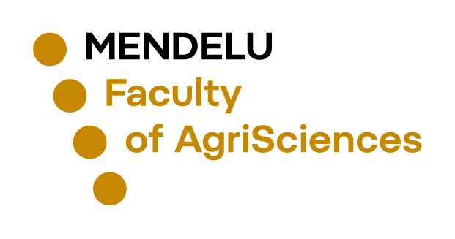

**Title**

Bachelor/Diploma thesis

*Supervisor: Author:*

Assoc. Prof. Karel Nový, Ph.D. Josef Novák

Brno 2025

*The assignment for the bachelor's / master's thesis, which is available to the student in pdf format in his/her UIS repository, will be inserted here.*

**Declaration**

I confirm by submitting that this thesis entitled Title was written and completed by me. I also declare that all the sources and information used to complete the thesis are included in the list of references. I agree that the thesis could be made public in accordance with Article 47b of Act No. 111/1998 Coll., on Higher Education Institutions and on Amendments and Supplements to Some Other Acts (the Higher Education Act), and in accordance with the current Directive on publishing of the final theses.

I am aware that my thesis is written in accordance to Act. 121/2000 Coll., on Copyright, and therefore Mendel University in Brno has the right to conclude licence agreements on the utilization of the thesis as a school work in accordance with Article 60(1) of the Copyright Act.

Before concluding a licence agreement on utilization of the work by another person, I will request a written statement from the university that the licence agreement is not in contradiction to legitimate interests of the university, and I will also pay a prospective fee to cover the cost incurred in creating the work to the full amount of such costs.

**Acknowledgement**

This part of the thesis is not mandatory but usual. Most often, thanks are given to the thesis supervisor, or consultant, and other researchers who assisted in e.g. designing the methodology, preparing the experiments, processing the data, etc. There are also acknowledgements to family members.

**Abstract**

The abstract should be in the range of 10-15 lines. Abstract, abstract, abstract, abstract, abstract, abstract, abstract, abstract, abstract, abstract, abstract, abstract, abstract, abstract, abstract, abstract, abstract, abstract, abstract, abstract, abstract, abstract, abstract, abstract, abstract, abstract, abstract, abstract, abstract, abstract, abstract, abstract, abstract, abstract, abstract, abstract, abstract, abstract, abstract, abstract, abstract, abstract, abstract, abstract, abstract, abstract, abstract, abstract, abstract, abstract, abstract, abstract, abstract, abstract, abstract, abstract, abstract, abstract, abstract, abstract, abstract, abstract, abstract, abstract, abstract, abstract, abstract, abstract, abstract, abstract, abstract, abstract, abstract, abstract, abstract, abstract, abstract, abstract, abstract, abstract, abstract, abstract, abstract, abstract, abstract, abstract, abstract, abstract, abstract, abstract, abstract, abstract, abstract, abstract, abstract, abstract, abstract, abstract, abstract, abstract, abstract, abstract, abstract, abstract.

Key words: word, word, word, word, word, word.

**Abstrakt**

Název bakalářské/diplomové práce:

Abstrakt, abstrakt, abstrakt, abstrakt, abstrakt, abstrakt, abstrakt, abstrakt, abstrakt, abstrakt, abstrakt, abstrakt, abstrakt, abstrakt, abstrakt, abstrakt, abstrakt, abstrakt, abstrakt, abstrakt, abstrakt, abstrakt, abstrakt, abstrakt, abstrakt, abstrakt, abstrakt, abstrakt, abstrakt, abstrakt, abstrakt, abstrakt, abstrakt, abstrakt, abstrakt, abstrakt, abstrakt, abstrakt, abstrakt, abstrakt, abstrakt, abstrakt, abstrakt, abstrakt, abstrakt, abstrakt, abstrakt, abstrakt, abstrakt, abstrakt, abstrakt, abstrakt, abstrakt, abstrakt, abstrakt, abstrakt, abstrakt, abstrakt, abstrakt, abstrakt, abstrakt, abstrakt, abstrakt, abstrakt, abstrakt, abstrakt, abstrakt, abstrakt, abstrakt, abstrakt, abstrakt, abstrakt, abstrakt, abstrakt, abstrakt, abstrakt, abstrakt, abstrakt, abstrakt, abstrakt, abstrakt, abstrakt, abstrakt, abstrakt, abstrakt, abstrakt, abstrakt, abstrakt, abstrakt, abstrakt, abstrakt, abstrakt, abstrakt, abstrakt, abstrakt, abstrakt, abstrakt, abstrakt, abstrakt, abstrakt, abstrakt, abstrakt, abstrakt, abstrakt, abstrakt, abstrakt, abstrakt, abstrakt, abstrakt, abstrakt.

Klíčová slova: slovo, slovo, slovo, slovo, slovo, slovo.