Tender from the project IGA24-AF-IP-0XX
Project solver: XYZ
Project garant: XYZ
- Bambu LAB X1C Carbon Combo 3D printer – CZK 42,500 (CHOSEN)
https://www.materialpro3d.cz/fdm-tiskarny/bambulab-x1c-combo/?gad=1&gclid=EAIaIQobChMIi4_qxeTd_gIV9pRoCR1x4AMnEAQYBSABEgLTPPD_BwE
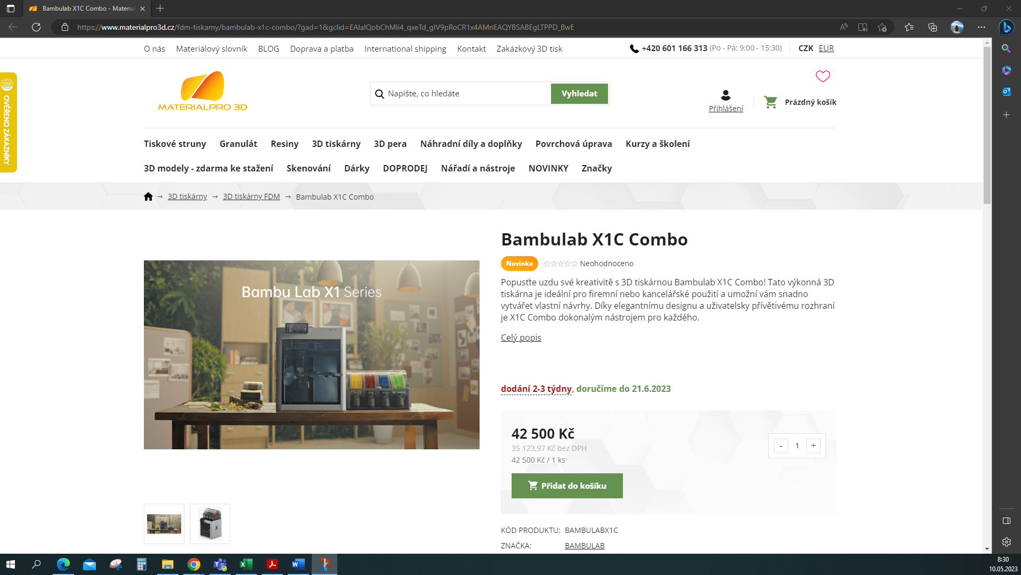
- Bambu LAB X1C Carbon Combo 3D printer – CZK 44,999
https://www.majkl3d.cz/p/bambu-lab-x1c-carbon-combo-multi-material?gclid=EAIaIQobChMI882Qmubd_gIVl4ZoCR1Y0AU8EAYYASABEgKjkvD_BwE
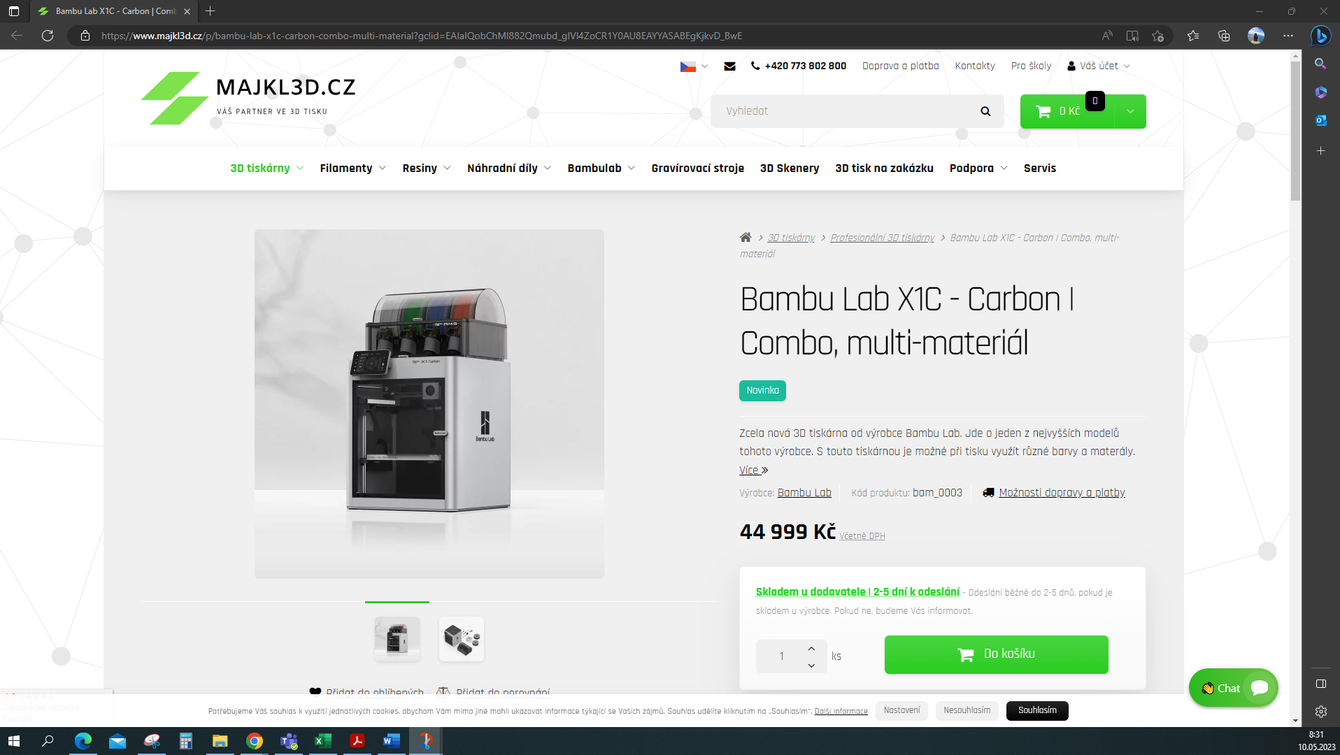
- Bambu LAB X1C Carbon Combo 3D printer – CZK 47,100
https://eshop.microware.cz/3d-tiskarny/600-bambu-lab-x1-carbon-combo-3d-printer.html
