Mendel University in Brno
Faculty of AgriSciences
BACHELOR/DIPLOMA THESIS
Brno 2024 Josef Novák

Mendel University in Brno
Faculty of AgriSciences
Department of xxxxxx
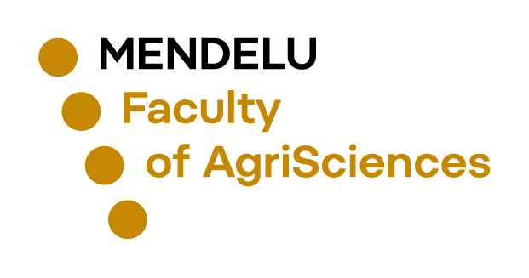
Title
Bachelor/Diploma thesis
Supervisor: Author:
Assoc. Prof. Karel Nový, Ph.D. Josef Novák
Brno 2024

The assignment of the bachelor/diploma thesis will be inserted here

Declaration

I hereby declare that, this thesis entitled „Title of bachelor/diploma thesis“ was written and completed by me. I also declare that all the sources and information used to complete the thesis are included in the list of references. I agree that the thesis could be made public in accordance with Article 47b of Act No. 111/1998 Coll., Higher Education Institutions and on Amendments and Supplements to Some Other Acts (the Higher Education Act), and in accordance with the current Directive on publishing of the final thesis. I declare that the printed version of the thesis and electronic version of the thesis published in the application of the Final Thesis in the University Information System is identical.
I am aware that my thesis is written in accordance to Act. 121/2000 Coll., on Copyright and therefore Mendel University in Brno has the right to conclude licence agreements on the utilization of the thesis as a school work in accordance with Article 60(1) of the Copyright Act.
Before concluding a licence agreement on utilization of the work by another person, I will request a written statement from the university that the licence agreement is not in contradiction to legitimate interests of the university, and I will also pay a prospective fee to cover the cost incurred in creating the work to the full amount of such costs.

In Brno date: …………………………
…………………………………………………
Signature

Acknowledgement
This part of the thesis is not mandatory.

Abstract
The abstract should be in the range of 10-15 lines. Abstract, abstract, abstract, abstract, abstract, abstract, abstract, abstract, abstract, abstract, abstract, abstract, abstract, abstract, abstract, abstract, abstract, abstract, abstract, abstract, abstract, abstract, abstract, abstract, abstract, abstract, abstract, abstract, abstract, abstract, abstract, abstract, abstract, abstract, abstract, abstract, abstract, abstract, abstract, abstract, abstract, abstract, abstract, abstract, abstract, abstract, abstract, abstract, abstract, abstract, abstract, abstract, abstract, abstract, abstract, abstract, abstract, abstract, abstract, abstract, abstract, abstract, abstract, abstract, abstract, abstract, abstract, abstract, abstract, abstract, abstract, abstract, abstract, abstract, abstract, abstract, abstract, abstract, abstract, abstract, abstract, abstract, abstract, abstract, abstract, abstract, abstract, abstract, abstract, abstract, abstract, abstract, abstract, abstract, abstract, abstract, abstract, abstract, abstract, abstract, abstract, abstract, abstract, abstract.
Key words: word, word, word, word, word, word.

Abstrakt
Název bakalářské/diplomové práce:
Abstrakt, abstrakt, abstrakt, abstrakt, abstrakt, abstrakt, abstrakt, abstrakt, abstrakt, abstrakt, abstrakt, abstrakt, abstrakt, abstrakt, abstrakt, abstrakt, abstrakt, abstrakt, abstrakt, abstrakt, abstrakt, abstrakt, abstrakt, abstrakt, abstrakt, abstrakt, abstrakt, abstrakt, abstrakt, abstrakt, abstrakt, abstrakt, abstrakt, abstrakt, abstrakt, abstrakt, abstrakt, abstrakt, abstrakt, abstrakt, abstrakt, abstrakt, abstrakt, abstrakt, abstrakt, abstrakt, abstrakt, abstrakt, abstrakt, abstrakt, abstrakt, abstrakt, abstrakt, abstrakt, abstrakt, abstrakt, abstrakt, abstrakt, abstrakt, abstrakt, abstrakt, abstrakt, abstrakt, abstrakt, abstrakt, abstrakt, abstrakt, abstrakt, abstrakt, abstrakt, abstrakt, abstrakt, abstrakt, abstrakt, abstrakt, abstrakt, abstrakt, abstrakt, abstrakt, abstrakt, abstrakt, abstrakt, abstrakt, abstrakt, abstrakt, abstrakt, abstrakt, abstrakt, abstrakt, abstrakt, abstrakt, abstrakt, abstrakt, abstrakt, abstrakt, abstrakt, abstrakt, abstrakt, abstrakt, abstrakt, abstrakt, abstrakt, abstrakt, abstrakt, abstrakt, abstrakt, abstrakt, abstrakt, abstrakt, abstrakt.
Klíčová slova: slovo, slovo, slovo, slovo, slovo, slovo.

